Scripts for Scene: **WTInside_Cantilever2**

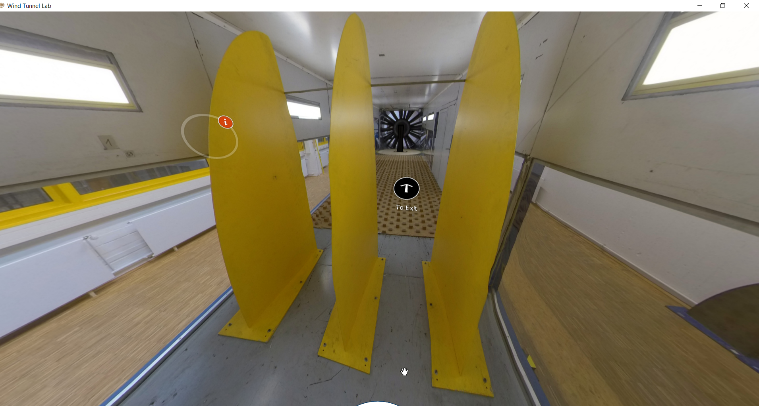

|  |  |  |
| --- | --- | --- |
| Nr | Hotspot (see red arrow) | Script |
| 1 | Hotspot: Castellated Barrier | Figure+Text:  Figure:    Text:  The first component to manipulate the wind flow, in the Counihan method, is castellated barrier. After the wind flow goes from inlet and the honeycomb mesh, castellated barrier is placed to reproduce large eddies. Reproduction of large eddies are a challenge in the wind tunnel experiment, but not impossible. |
| 2 | Hotspot: Turbulence generator | Slided figure+text (album)  Slide-1 Figure:    Slide-1 Text:  Turbulence generator or precisely, a Counihan Vortex Generators, is a component and a part of Counihan technique to experimentally simulate the turbulent flow in full-scale/reality. Flow from the inlet and after passing through the castellated barrier, will develop vortices with vertical axes around the Counihan vortex generators.  Slide-2 Figure:    Slide-2 Text:  The Counihan vortex generator has form of quarter-elliptic, constant-wedge-angle spires body. Height and number of vortex generator are important parameters to obtain the desired vortices which has to consider the cross-section of wind tunnel chamber. |